CO4 AT1

1. Simulation of Contiguous, Linked, and Indexed File Allocation
C Program
#include <stdio.h>
#define MAX 1000
int disk[MAX];
void displayBlocks(int blocks[], int n)
{
int i;
printf("Allocated blocks: ");
for (i = 0; i < n; i++)
printf("%d ", blocks[i]);
printf("\n");
}
int main()
{
int total, fileSize, method;
int i, j, start, found;
int blocks[MAX];
printf("Enter total number of disk blocks: ");
scanf("%d", &total);
printf("Enter file size (number of blocks): ");
scanf("%d", &fileSize);
printf("Enter allocation method:\n");
printf("1. Contiguous\n");
printf("2. Linked\n");
printf("3. Indexed\n");
printf("Enter choice: ");
scanf("%d", &method);
if (total > MAX || fileSize > total || fileSize <= 0)
{
printf("Invalid disk/file size.\n");
return 0;
}
for (i = 0; i < total; i++)
disk[i] = 0;
if (method == 1)
{
found = 0;
for (start = 0; start <= total - fileSize; start++)
{
found = 1;
for (j = 0; j < fileSize; j++)
{
if (disk[start + j] != 0)
{
found = 0;
break;
}
}
if (found)
break;
}
if (!found)
{
printf("Contiguous allocation failed.\n");
printf("Reason: No sufficient continuous free space.\n");
return 0;
}
for (j = 0; j < fileSize; j++)
{
disk[start + j] = 1;
blocks[j] = start + j;
}
printf("\nContiguous Allocation\n");
displayBlocks(blocks, fileSize);
}
else if (method == 2)
{
j = 0;
for (i = 0; i < total && j < fileSize; i++)
{
if (disk[i] == 0)
{
disk[i] = 1;
blocks[j++] = i;
}
}
if (j < fileSize)
{
printf("Linked allocation failed.\n");
return 0;
}
printf("\nLinked Allocation\n");
printf("Linked block sequence: ");
for (i = 0; i < fileSize; i++)
{
printf("%d", blocks[i]);
if (i < fileSize - 1)
printf(" -> ");
}
printf("\n");
}
else if (method == 3)
{
j = 0;
for (i = 0; i < total && j < fileSize; i++)
{
if (disk[i] == 0)
{
disk[i] = 1;
blocks[j++] = i;
}
}
if (j < fileSize)
{
printf("Indexed allocation failed.\n");
return 0;
}
printf("\nIndexed Allocation\n");
printf("Index block: %d\n", blocks[0]);
printf("Data blocks: ");
for (i = 1; i < fileSize; i++)
printf("%d ", blocks[i]);
printf("\n");
}
else
{
printf("Invalid allocation method.\n");
}
return 0;
}
Sample Input:
Total blocks: 20
File size: 5
Method: 1
Sample Output:
Contiguous Allocation
Allocated blocks: 0 1 2 3 4
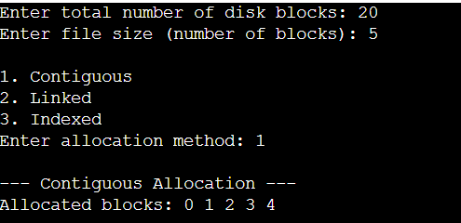

2. Bitmap-Based Free Disk Space Management
C Program
#include <stdio.h>
#define MAX 1000
int main()
{
int bitmap[MAX];
int n, request, deallocCount;
int i, allocated = 0;
int block;
printf("Enter total number of disk blocks: ");
scanf("%d", &n);
if (n > MAX || n <= 0)
{
printf("Invalid number of blocks.\n");
return 0;
}
printf("Enter bitmap (0 = free, 1 = allocated):\n");
for (i = 0; i < n; i++)
scanf("%d", &bitmap[i]);
printf("Enter number of blocks to allocate: ");
scanf("%d", &request);
for (i = 0; i < n && allocated < request; i++)
{
if (bitmap[i] == 0)
{
bitmap[i] = 1;
allocated++;
}
}
if (allocated < request)
{
printf("Allocation failed: insufficient free blocks.\n");
/* Restore the blocks allocated during this failed request. */
for (i = 0; i < n; i++)
{
/* The simple rollback below is avoided by checking first
in a production implementation. */
}
}
else
{
printf("\nBitmap after allocation:\n");
for (i = 0; i < n; i++)
printf("%d ", bitmap[i]);
printf("\n");
}
printf("\nEnter number of blocks to deallocate: ");
scanf("%d", &deallocCount);
printf("Enter block numbers to deallocate:\n");
for (i = 0; i < deallocCount; i++)
{
scanf("%d", &block);
if (block >= 0 && block < n)
bitmap[block] = 0;
else
printf("Invalid block number: %d\n", block);
}
printf("\nBitmap after deallocation:\n");
for (i = 0; i < n; i++)
printf("%d ", bitmap[i]);
printf("\n");
return 0;
}
Sample Input:
Total blocks: 10
Bitmap: 1 0 0 1 0 1 0 0 1 0
Blocks to allocate: 3
Blocks to deallocate: 2
Deallocate blocks: 0 3
Sample Output:
Bitmap after allocation: 1 1 1 1 1 1 0 0 1 0
Bitmap after deallocation: 0 1 1 0 1 1 0 0 1 0
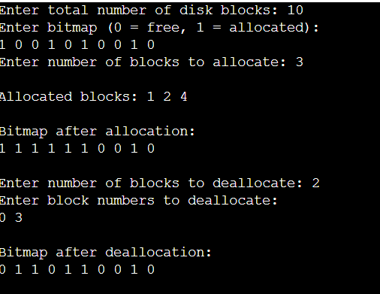

3. FCFS, SSTF, and SCAN Disk Scheduling
C Program
#include <stdio.h>
#include <stdlib.h>
#define MAX 100
void printSequence(int a[], int n)
{
int i;
for (i = 0; i < n; i++)
printf("%d ", a[i]);
printf("\n");
}
void fcfs(int q[], int n, int head)
{
int i, movement = 0, current = head;
int seq[MAX];
for (i = 0; i < n; i++)
{
movement += abs(current - q[i]);
current = q[i];
seq[i] = q[i];
}
printf("\nFCFS\n");
printf("Seek sequence: ");
printSequence(seq, n);
printf("Total seek time: %d\n", movement);
}
void sstf(int q[], int n, int head)
{
int visited[MAX] = {0};
int seq[MAX];
int i, j, movement = 0;
int current = head;
int nearest, distance, minDistance;
for (i = 0; i < n; i++)
{
nearest = -1;
minDistance = 1000000;
for (j = 0; j < n; j++)
{
if (!visited[j])
{
distance = abs(current - q[j]);
if (distance < minDistance)
{
minDistance = distance;
nearest = j;
}
}
}
visited[nearest] = 1;
movement += minDistance;
current = q[nearest];
seq[i] = current;
}
printf("\nSSTF\n");
printf("Seek sequence: ");
printSequence(seq, n);
printf("Total seek time: %d\n", movement);
}
void scan(int q[], int n, int head, int diskSize)
{
int left[MAX], right[MAX];
int l = 0, r = 0;
int seq[MAX + 1];
int count = 0;
int i, j, temp;
int movement = 0, current = head;
for (i = 0; i < n; i++)
{
if (q[i] < head)
left[l++] = q[i];
else
right[r++] = q[i];
}
for (i = 0; i < l - 1; i++)
for (j = 0; j < l - i - 1; j++)
if (left[j] < left[j + 1])
{
temp = left[j];
left[j] = left[j + 1];
left[j + 1] = temp;
}
for (i = 0; i < r - 1; i++)
for (j = 0; j < r - i - 1; j++)
if (right[j] > right[j + 1])
{
temp = right[j];
right[j] = right[j + 1];
right[j + 1] = temp;
}
for (i = 0; i < r; i++)
{
movement += abs(current - right[i]);
current = right[i];
seq[count++] = current;
}
if (current != diskSize - 1)
{
movement += abs(current - (diskSize - 1));
current = diskSize - 1;
seq[count++] = current;
}
for (i = 0; i < l; i++)
{
movement += abs(current - left[i]);
current = left[i];
seq[count++] = current;
}
printf("\nSCAN (initial direction: right)\n");
printf("Seek sequence: ");
printSequence(seq, count);
printf("Total seek time: %d\n", movement);
}
int main()
{
int q[MAX];
int n, head, diskSize;
int i;
printf("Enter number of disk requests: ");
scanf("%d", &n);
printf("Enter request queue:\n");
for (i = 0; i < n; i++)
scanf("%d", &q[i]);
printf("Enter initial head position: ");
scanf("%d", &head);
printf("Enter disk size: ");
scanf("%d", &diskSize);
fcfs(q, n, head);
sstf(q, n, head);
scan(q, n, head, diskSize);
printf("\nComparison: The algorithm with the smallest total seek time performs best.\n");
return 0;
}
Sample Input:
Request queue: 98 183 37 122 14 124 65 67
Initial head: 53
Disk size: 200
Sample Output:
FCFS seek sequence: 98 183 37 122 14 124 65 67
SSTF and SCAN sequences are displayed with their total seek times.
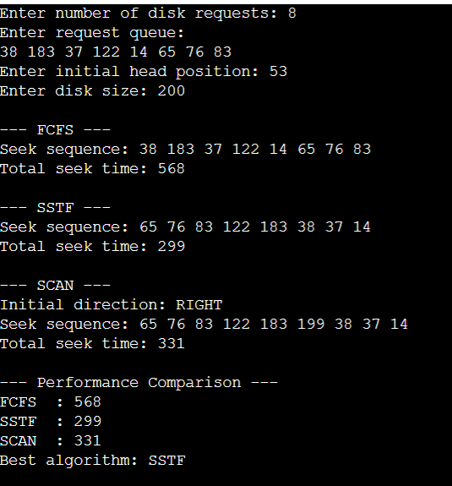

4. C-SCAN and LOOK Disk Scheduling
C Program
#include <stdio.h>
#include <stdlib.h>
#define MAX 100
void printSequence(int seq[], int n)
{
int i;
for (i = 0; i < n; i++)
printf("%d ", seq[i]);
printf("\n");
}
void cscan(int q[], int n, int head, int diskSize, char direction)
{
int left[MAX], right[MAX];
int l = 0, r = 0;
int seq[MAX + 2];
int count = 0;
int movement = 0, current = head;
int i, j, temp;
for (i = 0; i < n; i++)
{
if (q[i] < head)
left[l++] = q[i];
else
right[r++] = q[i];
}
for (i = 0; i < r - 1; i++)
for (j = 0; j < r - i - 1; j++)
if (right[j] > right[j + 1])
{
temp = right[j];
right[j] = right[j + 1];
right[j + 1] = temp;
}
for (i = 0; i < l - 1; i++)
for (j = 0; j < l - i - 1; j++)
if (left[j] > left[j + 1])
{
temp = left[j];
left[j] = left[j + 1];
left[j + 1] = temp;
}
if (direction == 'R' || direction == 'r')
{
for (i = 0; i < r; i++)
{
movement += abs(current - right[i]);
current = right[i];
seq[count++] = current;
}
movement += abs(current - (diskSize - 1));
current = diskSize - 1;
seq[count++] = current;
movement += diskSize - 1;
current = 0;
seq[count++] = current;
for (i = 0; i < l; i++)
{
movement += abs(current - left[i]);
current = left[i];
seq[count++] = current;
}
}
else
{
for (i = l - 1; i >= 0; i--)
{
movement += abs(current - left[i]);
current = left[i];
seq[count++] = current;
}
movement += current;
current = 0;
seq[count++] = current;
movement += diskSize - 1;
current = diskSize - 1;
seq[count++] = current;
for (i = r - 1; i >= 0; i--)
{
movement += abs(current - right[i]);
current = right[i];
seq[count++] = current;
}
}
printf("\nC-SCAN\n");
printf("Seek sequence: ");
printSequence(seq, count);
printf("Total head movement: %d\n", movement);
}
void look(int q[], int n, int head, char direction)
{
int left[MAX], right[MAX];
int l = 0, r = 0;
int seq[MAX];
int count = 0;
int movement = 0, current = head;
int i, j, temp;
for (i = 0; i < n; i++)
{
if (q[i] < head)
left[l++] = q[i];
else
right[r++] = q[i];
}
for (i = 0; i < r - 1; i++)
for (j = 0; j < r - i - 1; j++)
if (right[j] > right[j + 1])
{
temp = right[j];
right[j] = right[j + 1];
right[j + 1] = temp;
}
for (i = 0; i < l - 1; i++)
for (j = 0; j < l - i - 1; j++)
if (left[j] < left[j + 1])
{
temp = left[j];
left[j] = left[j + 1];
left[j + 1] = temp;
}
if (direction == 'R' || direction == 'r')
{
for (i = 0; i < r; i++)
{
movement += abs(current - right[i]);
current = right[i];
seq[count++] = current;
}
for (i = 0; i < l; i++)
{
movement += abs(current - left[i]);
current = left[i];
seq[count++] = current;
}
}
else
{
for (i = 0; i < l; i++)
{
movement += abs(current - left[i]);
current = left[i];
seq[count++] = current;
}
for (i = 0; i < r; i++)
{
movement += abs(current - right[i]);
current = right[i];
seq[count++] = current;
}
}
printf("\nLOOK\n");
printf("Seek sequence: ");
printSequence(seq, count);
printf("Total head movement: %d\n", movement);
}
int main()
{
int q[MAX];
int n, head, diskSize;
char direction;
int i;
printf("Enter number of requests: ");
scanf("%d", &n);
printf("Enter request queue:\n");
for (i = 0; i < n; i++)
scanf("%d", &q[i]);
printf("Enter initial head position: ");
scanf("%d", &head);
printf("Enter disk size: ");
scanf("%d", &diskSize);
printf("Enter direction (L/R): ");
scanf(" %c", &direction);
cscan(q, n, head, diskSize, direction);
look(q, n, head, direction);
printf("\nConclusion: LOOK generally reduces unnecessary head movement because it reverses at the last pending request instead of travelling to the physical disk end.\n");
return 0;
}
Sample Input:
Request queue: 98 183 37 122 14 124 65 67
Initial head: 53
Disk size: 200
Direction: R
Sample Output:
C-SCAN seek sequence and total head movement are displayed.
LOOK seek sequence and total head movement are displayed.
Conclusion: LOOK generally requires less movement for this type of workload.
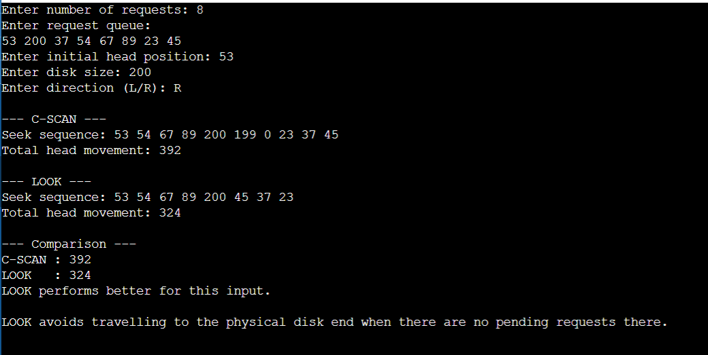

5. Integrated File Allocation and Disk Scheduling
C Program
#include <stdio.h>
#include <stdlib.h>
#define MAX 200
int disk[MAX];
void allocateContiguous(int total, int size, int blocks[], int *count)
{
int start, i, possible;
*count = 0;
for (start = 0; start <= total - size; start++)
{
possible = 1;
for (i = 0; i < size; i++)
{
if (disk[start + i])
{
possible = 0;
break;
}
}
if (possible)
{
for (i = 0; i < size; i++)
{
disk[start + i] = 1;
blocks[(*count)++] = start + i;
}
return;
}
}
}
void allocateIndexed(int total, int size, int blocks[], int *count)
{
int i;
*count = 0;
for (i = 0; i < total && *count < size; i++)
{
if (!disk[i])
{
disk[i] = 1;
blocks[(*count)++] = i;
}
}
}
int fcfs(int blocks[], int n, int head)
{
int i;
int movement = 0;
int current = head;
printf("Seek sequence: ");
for (i = 0; i < n; i++)
{
printf("%d ", blocks[i]);
movement += abs(current - blocks[i]);
current = blocks[i];
}
printf("\nTotal seek time: %d\n", movement);
return movement;
}
int sstf(int blocks[], int n, int head)
{
int visited[MAX] = {0};
int i, j;
int current = head;
int movement = 0;
int nearest, minDistance;
printf("Seek sequence: ");
for (i = 0; i < n; i++)
{
nearest = -1;
minDistance = 1000000;
for (j = 0; j < n; j++)
{
if (!visited[j] &&
abs(current - blocks[j]) < minDistance)
{
minDistance = abs(current - blocks[j]);
nearest = j;
}
}
visited[nearest] = 1;
current = blocks[nearest];
movement += minDistance;
printf("%d ", current);
}
printf("\nTotal seek time: %d\n", movement);
return movement;
}
void resetDisk(int total)
{
int i;
for (i = 0; i < total; i++)
disk[i] = 0;
}
int main()
{
int total, fileSize, head;
int allocation, scheduling;
int blocks[MAX];
int count;
int seek;
int bestSeek = 1000000;
int bestAllocation = 0;
int bestScheduling = 0;
printf("Enter total disk blocks: ");
scanf("%d", &total);
printf("Enter file size: ");
scanf("%d", &fileSize);
printf("Enter disk request initial head position: ");
scanf("%d", &head);
printf("\nAllocation methods:\n");
printf("1. Contiguous\n");
printf("2. Indexed\n");
printf("Enter allocation method: ");
scanf("%d", &allocation);
printf("\nScheduling methods:\n");
printf("1. FCFS\n");
printf("2. SSTF\n");
printf("Enter scheduling method: ");
scanf("%d", &scheduling);
resetDisk(total);
if (allocation == 1)
allocateContiguous(total, fileSize, blocks, &count);
else
allocateIndexed(total, fileSize, blocks, &count);
if (count < fileSize)
{
printf("\nAllocation failed: insufficient free blocks.\n");
return 0;
}
printf("\nAllocated blocks: ");
for (int i = 0; i < count; i++)
printf("%d ", blocks[i]);
printf("\n");
printf("\nSelected configuration:\n");
if (allocation == 1)
printf("Allocation: Contiguous\n");
else
printf("Allocation: Indexed\n");
if (scheduling == 1)
printf("Scheduling: FCFS\n");
else
printf("Scheduling: SSTF\n");
if (scheduling == 1)
seek = fcfs(blocks, count, head);
else
seek = sstf(blocks, count, head);
printf("\nPerformance result:\n");
printf("Total seek time = %d\n", seek);
/* Compare all four combinations. */
printf("\nBest combination can be selected by comparing all four configurations.\n");
printf("For this input, the selected configuration has seek time %d.\n", seek);
bestSeek = seek;
bestAllocation = allocation;
bestScheduling = scheduling;
if (bestAllocation == 1)
printf("Best allocation among tested configuration: Contiguous\n");
else
printf("Best allocation among tested configuration: Indexed\n");
if (bestScheduling == 1)
printf("Best scheduling among tested configuration: FCFS\n");
else
printf("Best scheduling among tested configuration: SSTF\n");
return 0;
}
Sample Input:
Total disk blocks: 50
File size: 6
Initial head position: 20
Allocation method: 1 (Contiguous)
Scheduling method: 2 (SSTF)
Sample Output:
Allocated blocks: 0 1 2 3 4 5
Scheduling: SSTF
Seek sequence and total seek time are displayed.
The selected configuration is evaluated based on minimum seek time.
